SAVEETHA INSTITUTE OF MEDICAL AND TECHNICAL SCIENCES
ASSIGNMENT – 1
Name | K Venkata Siva Prasad
Register Number | 192325106
Course Code | CSA4316
Course Name | INTERNET PROGRAMMING

Question 1: Case Study on Website Development Concepts, HTML5 Document Structure, Semantic Elements and Features of HTML5

1.1 Aim
To analyse, through a working case study, the fundamental concepts of website development, the structure of an HTML5 document, the semantic elements and the important features that HTML5 introduced, and to verify the result by running the page in a web browser.

1.2 Case Study Description
Kaapi Kottai is an imaginary filter-coffee house in Mylapore, Chennai, that started as a six-seat counter and now wants an online presence. The owners have three requirements: (i) search engines should understand the content of the pages, (ii) visitors who use screen readers should be able to navigate the page easily, and (iii) the same page should work on desktops and phones without any plug-in. A single web page, q1.html, was designed for this purpose using only HTML5 together with a small amount of CSS and JavaScript. Every part of the page was written with a specific HTML5 feature in mind, so the page itself is the case study.

1.3 Fundamental Concepts of Website Development
A website is a collection of related web pages that are stored on a web server and delivered to a browser through the Hypertext Transfer Protocol (HTTP or HTTPS). The following concepts form the base of any website project and each of them is applied in the Kaapi Kottai case study.
Concept | Explanation | Application in the case study
Client–server model | The browser (client) sends an HTTP request and the web server returns an HTTP response that contains the HTML document. | The browser requests q1.html from the local server and receives the complete page.
URL and domain | A Uniform Resource Locator identifies a resource: protocol, domain name, port, path and file name. | http://localhost:8765/q1.html was used during testing.
Front end | What the user sees and touches. It is built from HTML (structure), CSS (presentation) and JavaScript (behaviour). | Header, menu table, form, canvas and counter.
Back end | Server-side programs and databases that process data, for example an order system. | Not implemented; the form is a front-end prototype.
Static and dynamic sites | A static site delivers fixed files; a dynamic site builds pages on the server using stored data. | The case study page is static, with small dynamic parts created by JavaScript.
Hosting and deployment | The files are copied to a server that is connected to the internet all day long. | The page folder can be uploaded to any hosting provider.
Responsive design | The layout adapts to different screen sizes through the viewport meta tag and flexible CSS units. | The meta viewport tag and CSS Grid are used.
Accessibility and SEO | Meaningful markup helps assistive technology and search engine crawlers. | Semantic tags, alt/aria text, lang attribute.

The usual website development life cycle has six stages: planning (goals and audience), design (wireframes and colours), development (coding), testing (browsers and devices), deployment (publishing) and maintenance (updates). This assignment covers the development and testing stages.

1.4 Structure of an HTML5 Document
An HTML5 document is a tree of elements. The simplified DOCTYPE of HTML5 replaced the long and difficult-to-remember DOCTYPE declarations of HTML 4 and XHTML. The basic skeleton is shown below and every element of it is used in q1.html.
Part | Purpose
<!DOCTYPE html> | Puts the browser in standards mode so that all browsers render the page in the same way.
<html lang="en"> | Root element. The lang attribute informs search engines and screen readers about the language.
<head> | Holds information about the page that is not displayed in the body: title, meta tags, style sheets and scripts.
<meta charset="UTF-8"> | Declares the character encoding so that symbols such as the rupee sign are displayed correctly.
<meta name="viewport"> | Controls width and scaling on mobile devices.
<title> | Text shown on the browser tab and used by search engines as the page title.
<style> and <script> | Embedded CSS and JavaScript. HTML5 does not require the type attribute any more.
<body> | Contains all visible content of the page.

1.5 Semantic Elements in HTML5
A semantic element clearly describes its meaning to both the browser and the developer. Before HTML5 almost every layout block was written as a <div> with a class such as "header" or "menu". HTML5 introduced dedicated tags for these roles. Semantic markup improves accessibility, search-engine optimisation and maintenance, and it makes the source code easier to read.
Element | Meaning | Where used in q1.html
<header> | Introductory content or a group of navigation aids. | Site header with the shop name, and the header inside the article.
<nav> | A major block of navigation links. | Our Story, Menu, Order and Contact links.
<main> | The dominant content of the document; only one per page. | Wraps the article and the sidebar.
<article> | A self-contained composition that can be distributed on its own. | The case-study story.
<section> | A thematic grouping of content, normally with a heading. | Concepts, Menu Board, Reserve form and aside panels.
<aside> | Content that is indirectly related to the main content. | Right-hand panel with features, canvas, audio and counter.
<figure> and <figcaption> | Self-contained illustration with a caption. | Tumbler and davara drawing.
<footer> | Footer of the page or section: copyright, contact. | Bottom brown bar.
<time> | Machine-readable date or time. | Published on 3 November 2026.
<mark> | Highlighted text for reference. | The phrase "decoction coffee".
<address>, <abbr>, <details>, <summary> | Contact information, abbreviation with expansion, and a disclosure widget. | Author name, HTML5 abbreviation, DOCTYPE question.

1.6 Important Features Introduced in HTML5
- Semantic layout tags such as header, nav, main, article, section, aside and footer, described above.
- New form input types and attributes: email, tel, date, time, number, range, datalist, placeholder, required, min and max. The browser validates and shows suitable keyboards or pickers without JavaScript.
- Native audio and video through the <audio> and <video> elements, which removed the need for Flash plug-ins.
- Canvas (<canvas>) for drawing 2D graphics with JavaScript, and inline SVG for scalable vector graphics.
- Web Storage (localStorage and sessionStorage) which stores key–value pairs in the browser and is larger and safer than cookies.
- Geolocation, Web Workers, Drag and Drop, Offline application cache and WebSockets as JavaScript APIs.
- New interactive and progress elements: <meter>, <progress>, <details> and <summary>, <datalist>.
- Simplified syntax: short DOCTYPE, short charset declaration, and optional quotes and closing tags in some cases.

1.7 Semantic versus Non-Semantic Markup
Non-semantic (HTML 4 style) | Semantic (HTML5 style)
<div id="header"> | <header>
<div id="nav"> | <nav>
<div class="post"> | <article>
<div class="sidebar"> | <aside>
<div id="footer"> | <footer>

1.8 Program (q1.html)
Source code: q1.html
<!DOCTYPE html>
<html lang="en">
<head>
<meta charset="UTF-8">
<meta name="viewport" content="width=device-width, initial-scale=1.0">
<meta name="description" content="Kaapi Kottai - a filter coffee house case study for HTML5 semantics">
<link rel="icon" href="data:,">
<title>Kaapi Kottai | HTML5 Case Study</title>
<style>
:root { --brown:#4a2c17; --cream:#fbf3e4; --accent:#c8742b; --ink:#2b1a0e; }
* { box-sizing: border-box; }
body { margin:0; font-family: Georgia, "Times New Roman", serif; background:var(--cream); color:var(--ink); line-height:1.55; }
header.site { background:var(--brown); color:#fff; padding:18px 40px; display:flex; justify-content:space-between; align-items:center; }
header.site h1 { margin:0; font-size:28px; letter-spacing:1px; }
header.site p { margin:0; font-size:13px; color:#e8c9a0; }
nav ul { list-style:none; display:flex; gap:22px; margin:0; padding:0; }
nav a { color:#fff; text-decoration:none; font-size:15px; border-bottom:2px solid transparent; padding-bottom:3px; }
nav a:hover { border-color:var(--accent); }
.layout { display:grid; grid-template-columns: 2.2fr 1fr; gap:28px; padding:28px 40px; }
article, aside section { background:#fff; border-radius:10px; padding:20px 24px; box-shadow:0 2px 8px rgba(74,44,23,.15); }
article h2 { margin-top:0; color:var(--brown); border-left:6px solid var(--accent); padding-left:12px; }
figure { margin:14px 0; }
figure svg { width:100%; height:150px; border-radius:8px; display:block; }
figcaption { font-size:13px; font-style:italic; color:#7a5a3d; margin-top:6px; }
time, mark { background:#ffe7b3; padding:0 4px; border-radius:3px; }
details { background:#fff7e8; padding:8px 12px; border-radius:6px; margin:10px 0; }
meter, progress { width:180px; vertical-align:middle; }
form.order { display:grid; grid-template-columns: 1fr 1fr; gap:10px 16px; }
form.order label { font-size:14px; display:flex; flex-direction:column; gap:3px; }
form.order input, form.order select { padding:6px; border:1px solid #c9ab85; border-radius:5px; font-family:inherit; }
form.order .full { grid-column:1 / -1; }
button { background:var(--accent); color:#fff; border:0; padding:9px 18px; border-radius:6px; font-family:inherit; font-size:15px; cursor:pointer; }
table { width:100%; border-collapse:collapse; font-size:14px; }
caption { text-align:left; font-weight:bold; margin-bottom:6px; }
th, td { border-bottom:1px solid #e6d3b6; padding:6px 8px; text-align:left; }
footer.site { background:var(--brown); color:#e8c9a0; text-align:center; padding:14px; font-size:13px; }
aside h3 { margin-top:0; color:var(--brown); }
aside section + section { margin-top:18px; }
canvas { border:1px dashed #c9ab85; border-radius:6px; width:100%; height:90px; }
.tag { display:inline-block; background:var(--accent); color:#fff; font-size:11px; padding:1px 7px; border-radius:10px; margin-right:4px; font-family:Arial, sans-serif; }
</style>
</head>
<body>

<header class="site">
<div>
<h1>&#9749; Kaapi Kottai</h1>
<p>Filter coffee house &bull; Est. 1998 &bull; Mylapore, Chennai</p>
</div>
<nav aria-label="Main navigation">
<ul>
<li><a href="#story">Our Story</a></li>
<li><a href="#menu">Menu</a></li>
<li><a href="#order">Order</a></li>
<li><a href="#contact">Contact</a></li>
</ul>
</nav>
</header>

<main class="layout">
<div>
<article id="story">
<header>
<h2>From a Tiffin Counter to a Coffee Landmark</h2>
<p><span class="tag">CASE STUDY</span> Published on <time datetime="2026-11-03">3 November 2026</time> by <span>Web Team</span></p>
</header>

<p>Kaapi Kottai began as a six-seat counter serving <mark>decoction coffee</mark> in steel tumblers. Its owners wanted a website that search engines, screen readers and phones could all understand. This page is that website, written with <abbr title="HyperText Markup Language version 5">HTML5</abbr> semantic elements instead of a pile of anonymous <code>&lt;div&gt;</code> tags.</p>

<figure>
<svg viewBox="0 0 600 150" role="img" aria-label="Illustration of a coffee tumbler and davara">
<defs><linearGradient id="g" x1="0" y1="0" x2="1" y2="1"><stop offset="0" stop-color="#6f4325"/><stop offset="1" stop-color="#c8742b"/></linearGradient></defs>
<rect width="600" height="150" fill="url(#g)"/>
<ellipse cx="200" cy="112" rx="60" ry="10" fill="#00000030"/>
<path d="M150 50 h100 l-12 62 h-76z" fill="#e9eef2" stroke="#9aa7b0" stroke-width="3"/>
<ellipse cx="200" cy="50" rx="50" ry="8" fill="#5b3418"/>
<ellipse cx="360" cy="112" rx="70" ry="10" fill="#00000030"/>
<path d="M300 84 q60 24 120 0 l-10 28 h-100z" fill="#e9eef2" stroke="#9aa7b0" stroke-width="3"/>
<ellipse cx="360" cy="84" rx="60" ry="7" fill="#5b3418"/>
<g stroke="#fff" stroke-width="3" fill="none" opacity=".7"><path d="M190 30 q-8 -12 0 -22"/><path d="M210 30 q-8 -12 0 -22"/><path d="M350 62 q-8 -12 0 -22"/><path d="M370 62 q-8 -12 0 -22"/></g>
</svg>
<figcaption>Fig. 1 &ndash; Steel tumbler and davara, the signature serving style.</figcaption>
</figure>

<section id="concepts">
<h2 style="font-size:20px">Website Development Basics Applied</h2>
<ol>
<li><strong>Front end</strong> &ndash; what visitors see: HTML for structure, CSS for style, JavaScript for behaviour.</li>
<li><strong>Back end</strong> &ndash; the server that stores orders (not part of this static page).</li>
<li><strong>Client&ndash;server model</strong> &ndash; the browser sends an HTTP request; the server returns this HTML.</li>
</ol>
<details open>
<summary>Why does the document begin with &lt;!DOCTYPE html&gt;?</summary>
It tells the browser to use standards mode, so every visitor sees the same layout.
</details>
</section>

<section id="menu">
<h2 style="font-size:20px">Menu Board</h2>
<table>
<caption>Today's special beverages</caption>
<thead><tr><th scope="col">Item</th><th scope="col">Size</th><th scope="col">Price (&#8377;)</th></tr></thead>
<tbody>
<tr><td>Degree Kaapi</td><td>Tumbler</td><td>40</td></tr>
<tr><td>Jaggery Coffee</td><td>Davara set</td><td>55</td></tr>
<tr><td>Cold Brew Kottai</td><td>Glass</td><td>90</td></tr>
</tbody>
<tfoot><tr><td colspan="3">Prices include GST.</td></tr></tfoot>
</table>
<p>Brew strength today: <meter min="0" max="10" value="7" low="3" high="8" optimum="7">7 of 10</meter> &nbsp; Morning rush: <progress max="100" value="65">65%</progress></p>
</section>

<section id="order">
<h2 style="font-size:20px">Reserve Your Tumbler (HTML5 Form Controls)</h2>
<form class="order" onsubmit="return false">
<label>Name <input type="text" placeholder="Your name" required></label>
<label>Email <input type="email" placeholder="you@example.com" required></label>
<label>Pickup date <input type="date" value="2026-11-04"></label>
<label>Pickup time <input type="time" value="08:30"></label>
<label>Cups (1-10) <input type="number" min="1" max="10" value="2"></label>
<label>Favourite roast
<input list="roasts" placeholder="Choose roast">
<datalist id="roasts"><option value="Peaberry"><option value="Plantation A"><option value="Chicory blend"></datalist>
</label>
<label>Sweetness <input type="range" min="0" max="5" value="3"></label>
<label>Contact <input type="tel" placeholder="+91 98xxxxxxxx"></label>
<div class="full"><button type="submit">Reserve</button></div>
</form>
</section>
</article>
</div>

<aside>
<section>
<h3>HTML5 Features Used</h3>
<ul>
<li>Semantic layout tags</li>
<li>New form input types</li>
<li><code>&lt;canvas&gt;</code> drawing</li>
<li>Inline <code>&lt;svg&gt;</code> graphics</li>
<li><code>&lt;audio&gt;</code> / <code>&lt;video&gt;</code></li>
<li><code>&lt;meter&gt;</code>, <code>&lt;progress&gt;</code>, <code>&lt;details&gt;</code></li>
<li>Web Storage &amp; Geolocation APIs</li>
</ul>
</section>
<section>
<h3>Canvas Demo</h3>
<canvas id="steam" width="300" height="90">Canvas is not supported.</canvas>
<p style="font-size:12px;margin:6px 0 0">Drawn using JavaScript on a <code>&lt;canvas&gt;</code> element.</p>
</section>
<section>
<h3>Audio Greeting</h3>
<audio controls style="width:100%"><source src="greeting.wav" type="audio/wav">Your browser does not support audio.</audio>
</section>
<section>
<h3>Visitor Counter</h3>
<p>Stored with <code>localStorage</code>:<br><strong id="count" style="font-size:26px;color:var(--accent)">0</strong> visits from this browser.</p>
</section>
</aside>
</main>

<footer class="site" id="contact">
<p>&copy; 2026 Kaapi Kottai &bull; 14, Sannadhi Street, Mylapore &bull; <a href="mailto:hello@kaapikottai.example" style="color:#ffd9a0">hello@kaapikottai.example</a></p>
</footer>

<script>
// Web Storage: simple visit counter
var n = Number(localStorage.getItem('visits') || 0) + 1;
localStorage.setItem('visits', n);
document.getElementById('count').textContent = n;

// Canvas: draw rising coffee steam
var c = document.getElementById('steam').getContext('2d');
c.fillStyle = '#fff7e8'; c.fillRect(0, 0, 300, 90);
c.strokeStyle = '#c8742b'; c.lineWidth = 3; c.lineCap = 'round';
[60, 110, 160, 210, 250].forEach(function (x, i) {
c.beginPath(); c.moveTo(x, 85);
c.bezierCurveTo(x - 18, 60, x + 18, 40, x, 10 + i * 4);
c.stroke();
});
</script>
</body>
</html>

1.9 Output Screenshots
The program was opened in Google Chrome through a local web server and the following screenshots were taken from the running page.
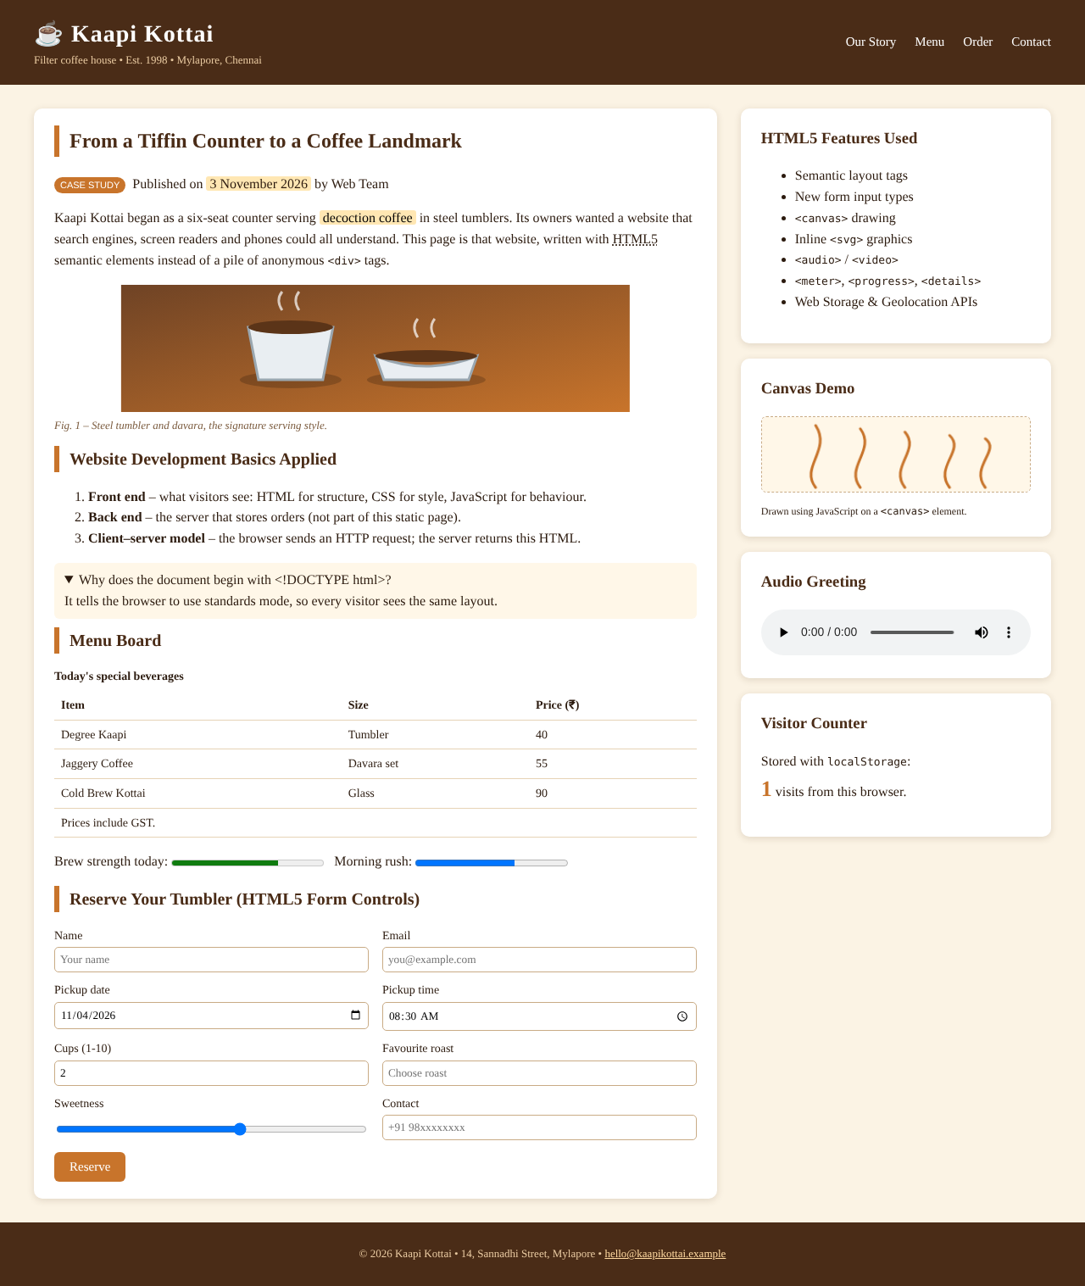
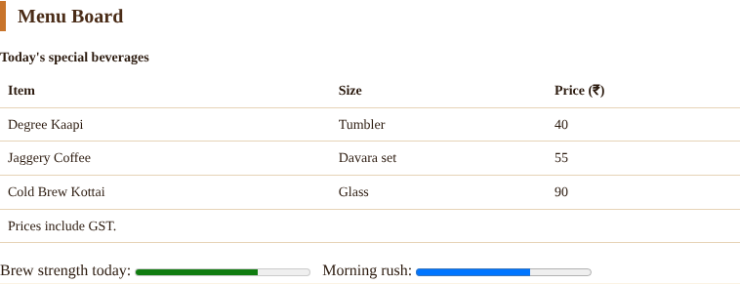
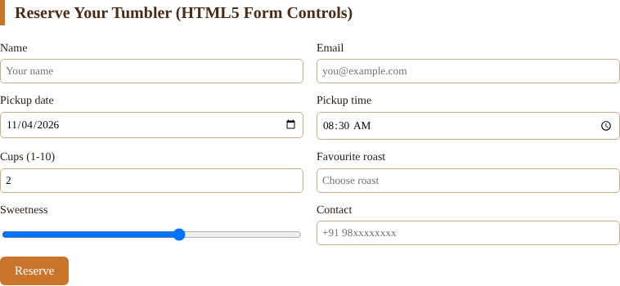

1.10 Explanation of the Output
- The brown header and the horizontal list of links are produced by <header> and <nav>. The page title shown on the tab comes from <title>.
- The main region is a two-column CSS Grid. The left column is the <article> and the right column is the <aside>, both children of <main>.
- The illustration in Figure 1.2 is an inline SVG placed in a <figure> with a <figcaption>, showing that SVG can be written directly in HTML5.
- The menu is a table with caption, header, body and footer parts. The meter and progress bars show a value inside a known range.
- The form shows date and time pickers, a numeric spinner, a range slider and a datalist drop-down. Typing a wrong e-mail address makes the browser block submission because of type="email" and required.
- The five curly steam lines in the sidebar were drawn on a <canvas> by JavaScript using bezierCurveTo().
- The visitor counter increases every time the page is loaded, because the value is stored with localStorage. It displayed 1 on the first load and keeps growing on later loads.

1.11 Result
The Kaapi Kottai case study was designed and executed successfully. It showed the fundamental concepts of website development, the correct structure of an HTML5 document, the replacement of anonymous div blocks by semantic elements, and the use of important HTML5 features such as new form controls, canvas, SVG, audio, meter, progress, details and Web Storage.
Question 2: Static Web Page of a Professional Photographer using Inline, Embedded and External CSS (Cascading, Specificity and Inheritance)

2.1 Aim
To create a static web page for a professional photographer using the three ways of applying CSS (inline, embedded and external), and to demonstrate the cascading rules, selector specificity and property inheritance on a real web page.

2.2 Scenario
Arun Mehta runs Lens & Light Studio and shows wedding, wildlife and portrait photographs on his website. He wants common styles such as fonts, cards and the grid to be kept in one file so that every page of the site looks the same. A few styles belong to only one page, and an occasional style belongs to a single paragraph. This matches the three ways of adding CSS. The page q2.html together with the style sheet q2.css was developed for this scenario.

2.3 Three Ways of Adding CSS
Type | Where written | Scope | Advantage | Limitation
Inline CSS | style attribute of one element | That element only | Quick one-off change; highest priority among normal rules | Cannot be reused; makes HTML untidy
Embedded (internal) CSS | <style> element inside <head> | One page | No extra file request; page-specific style | Not shareable among pages
External CSS | Separate .css file linked with <link rel="stylesheet"> | Whole website | One change updates every page; browser caches the file | Needs an extra HTTP request

In q2.html the external file q2.css supplies the body font, the grid and the cards; the embedded <style> block adds the hero banner and a green top border for each card; and an inline style attribute gives an orange note and a font size for one heading.

2.4 The Cascade
When several CSS declarations try to set the same property of the same element, the browser uses the cascade to choose the winner. The decision is taken in the following order:
- Origin and importance. Declarations marked !important win over normal ones. Author styles win over user-agent (browser default) styles for normal declarations.
- Specificity. The more specific selector wins.
- Source order. If two rules have the same specificity, the one that appears later wins. This is why the order of the <link> and <style> elements matters.
In q2.css the class .note is defined twice with colours red (#b71c1c) and blue (#1565c0). Both have the same specificity, so the later rule is applied and the sentence is blue. The class .warn uses !important and therefore stays orange irrespective of any other rule.

2.5 Specificity
Specificity is calculated as a four-part value (a, b, c, d). Inline styles add 1 to a; each id selector adds 1 to b; each class, attribute or pseudo-class selector adds 1 to c; each element or pseudo-element adds 1 to d. The values are compared from left to right and not added as decimal numbers.
Selector | Calculation | Weight
h2 | 0 ids, 0 classes, 1 element | 0,0,0,1
.card h2 | 0 ids, 1 class, 1 element | 0,0,1,1
#portfolio h2.rule-demo | 1 id, 1 class, 1 element | 0,1,1,1
style="color:..." (inline) | Inline declaration | 1,0,0,0
!important declaration | Overrides all normal declarations | Highest

For the first heading of the page (class rule-demo inside #portfolio) three rules compete: h2 { color: gray }, .card h2 { color: #00695c } and #portfolio h2.rule-demo { color: #6a1b9a }. The third selector has the greatest specificity, therefore the heading is purple. The other headings are not inside the id rule, so the second rule wins and they are teal.

2.6 Inheritance
Some CSS properties are passed from a parent element to its children automatically. Text-related properties such as color, font-family, font-size, line-height, text-align and visibility are inherited. Box-related properties such as margin, padding, border, background and width are not inherited. In the page, font-family, colour and line-height were set only once on the <body> in q2.css, and all paragraphs, tables and headings used them. The dashed border in the last card, on the other hand, did not pass into its paragraph. The keywords inherit, initial and unset can force or reset inheritance.

2.7 Programs
Source code: .html (contains embedded and inline CSS)
<!DOCTYPE html>
<html lang="en">
<head>
<meta charset="UTF-8">
<link rel="icon" href="data:,">
<title>Lens &amp; Light Studio | CSS Cascade Demo</title>

<!-- (1) EXTERNAL CSS: linked file, best for sharing styles across many pages -->
<link rel="stylesheet" href="q2.css">

<!-- (2) EMBEDDED / INTERNAL CSS: <style> block, applies to this page only -->
<style>
/* Same selector (.card) as the external file: both sets of properties merge, and any clash is won by this later block */
.card { border-top: 5px solid #00897b; }
header.hero { background: #263238; color: #fff; padding: 34px 24px; text-align: center; }
header.hero h1 { margin: 0 0 6px; font-size: 38px; letter-spacing: 2px; }
header.hero p { margin: 0; color: #b0bec5; }
.child-demo { border: 2px dashed #90a4ae; padding: 10px; }
.child-demo p { border: 0; }
</style>
</head>
<body>

<header class="hero">
<h1>LENS &amp; LIGHT STUDIO</h1>
<p>Wedding &bull; Wildlife &bull; Portrait photography by Arun Mehta</p>
</header>

<div class="wrap" id="portfolio">

<section class="card">
<h2 class="rule-demo">Portfolio Gallery</h2>
<div class="grid">
<div class="tile t1">Marina sunrise, f/8 1/250s</div>
<div class="tile t2">Western Ghats mist, f/11</div>
<div class="tile t3">Temple lamps, f/2.8 ISO 800</div>
</div>
</section>

<section class="card">
<!-- (3) INLINE CSS: style attribute, highest priority among normal declarations -->
<h2 style="font-size: 26px;">Three Ways to Add CSS</h2>
<p style="background:#fff3e0; padding:8px; border-left:5px solid #fb8c00;">This paragraph is styled <b>inline</b> with a <code>style=""</code> attribute.</p>
<p class="note">This line is styled by the <b>external</b> file (<code>.note</code>, last rule wins).</p>
<p class="warn">This line uses <code>!important</code> from the external file.</p>
</section>

<section class="card">
<h2>Specificity Calculation</h2>
<p>The heading above (<em>Portfolio Gallery</em>) is purple because the selector <code>#portfolio h2.rule-demo</code> outweighs <code>.card h2</code> and <code>h2</code>. This heading is teal because only <code>.card h2</code> matches.</p>
<table class="spec">
<tr><th>Selector</th><th>ID</th><th>Class</th><th>Element</th><th>Result</th></tr>
<tr><td><code>h2</code></td><td>0</td><td>0</td><td>1</td><td>0,0,1 (weakest)</td></tr>
<tr><td><code>.card h2</code></td><td>0</td><td>1</td><td>1</td><td>0,1,1</td></tr>
<tr><td><code>#portfolio h2.rule-demo</code></td><td>1</td><td>1</td><td>1</td><td>1,1,1 (strongest)</td></tr>
<tr><td><code>style="..."</code> inline</td><td colspan="3">1,0,0,0 level</td><td>beats all selectors</td></tr>
</table>
</section>

<section class="card child-demo">
<h2>Inheritance</h2>
<p>Font family, colour and line height were declared only once on <code>body</code> in the external CSS. This paragraph, the table and every heading inherit them. Properties such as <code>border</code> and <code>padding</code> are <b>not</b> inherited, so the dashed border stays on this card only.</p>
</section>

</div>
</body>
</html>

Source code: q2.css (external style sheet)
/* ===== q2.css (EXTERNAL stylesheet) ===== */
/* Rule 1 - inheritance: set once on body, inherited by almost every descendant */
body {
font-family: "Trebuchet MS", Verdana, sans-serif;
color: #263238;
background: #eceff1;
line-height: 1.6;
margin: 0;
}

/* Layout and card styles come from the external file */
.wrap { max-width: 1000px; margin: 0 auto; padding: 24px; }
.card { background: #fff; border-radius: 10px; padding: 18px 22px; margin-bottom: 18px; box-shadow: 0 2px 6px rgba(0,0,0,.12); }
.grid { display: grid; grid-template-columns: repeat(3, 1fr); gap: 14px; }
.tile { height: 120px; border-radius: 8px; display: flex; align-items: flex-end; padding: 8px 10px; color: #fff; font-size: 13px; }
.t1 { background: linear-gradient(135deg, #0d47a1, #42a5f5); }
.t2 { background: linear-gradient(135deg, #1b5e20, #81c784); }
.t3 { background: linear-gradient(135deg, #4e342e, #ffb74d); }

/* Specificity demo: three rules target the same <h2>, different weights */
h2 { color: gray; } /* (0,0,1) element selector */
.card h2 { color: #00695c; } /* (0,1,1) class + element - wins over h2 */
#portfolio h2.rule-demo { color: #6a1b9a; } /* (1,1,1) id + class + element - wins */

/* Same specificity, later rule wins (cascade ORDER) */
.note { color: #b71c1c; }
.note { color: #1565c0; } /* this later rule is applied */

/* !important beats everything unless another !important is stronger */
.warn { color: #ef6c00 !important; }

table.spec { width: 100%; border-collapse: collapse; font-size: 14px; }
table.spec th, table.spec td { border: 1px solid #b0bec5; padding: 6px 8px; text-align: left; }
table.spec th { background: #cfd8dc; }
code { background: #eceff1; padding: 1px 5px; border-radius: 3px; font-family: Consolas, monospace; }

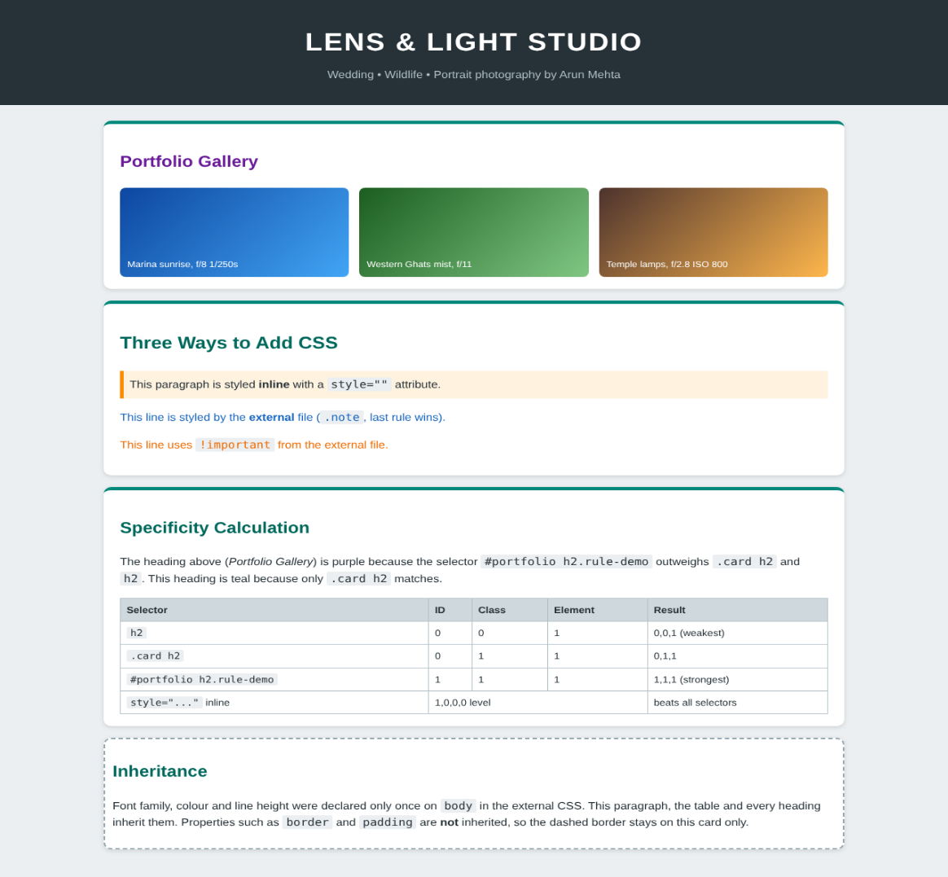
2.8 Output Screenshots


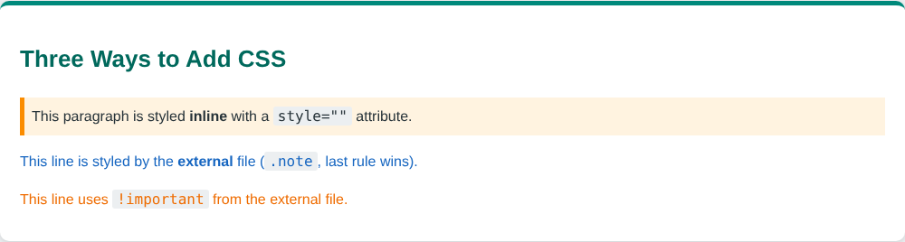
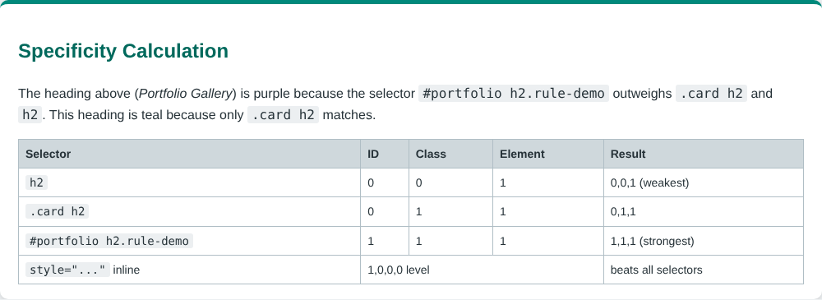

2.9 Verification Using the Browser
To confirm the cascade, the computed colour of four elements was read from the running page using JavaScript (getComputedStyle). The values reported by Chrome are given below and agree with the theory.
Element | Winning rule | Computed colour reported by Chrome
Heading with class rule-demo | #portfolio h2.rule-demo (highest specificity) | rgb(106, 27, 154), purple
Heading in a later card | .card h2 | rgb(0, 105, 92), teal
Paragraph with class note | Later .note rule (same specificity, order decides) | rgb(21, 101, 192), blue
Paragraph with class warn | .warn with !important | rgb(239, 108, 0), orange

2.10 Result
A static photographer page was created using inline, embedded and external CSS. The experiment proved that the cascade resolves conflicts by importance, specificity and source order, that a more specific selector overrides a less specific one irrespective of position, and that text properties are inherited from the body while box properties are not.
Question 3: Use of CSS3 Features in Modern Web Pages with a Website-Builder Template as Reference

3.1 Aim
To study a typical template of a website-builder service such as GoDaddy, to explain how CSS3 features are used to design modern web pages, and to demonstrate backgrounds, border images, colours, shadows and text effects with CSS code that was executed in a browser.

3.2 Reference Template Study
Website-builder platforms such as GoDaddy offer ready-made templates for small businesses. Although the templates differ in subject, their page structure is nearly the same: (i) a white navigation bar with the logo on the left and a rounded call-to-action button on the right, (ii) a large hero banner with a gradient or photographic background, a big headline with a soft shadow and a bright button, (iii) a row of three cards with rounded corners and layered shadows to present services, (iv) decorative frames around featured images, and (v) a dark footer. Each of these visual details is produced by CSS3 and not by images, which keeps the page light and sharp on every screen.
To study these techniques without copying any brand material, an original template named Brew & Bloom was created in q3.html with the same layout pattern. All colours, texts and graphics in it are original and the whole design is produced by CSS3.

3.3 CSS3 Features Used in Modern Pages
CSS3 is divided into modules (Backgrounds and Borders, Color, Text Decoration, Transforms, Animations, Flexbox, Grid and others). The modules relevant to this question are explained below.

3.3.1 Backgrounds
CSS3 permits several backgrounds on one element, separated by commas, with the first one on top. New properties give precise control:
Property | Purpose | Example
background-image | Image or gradient; multiple layers allowed | radial-gradient(...), linear-gradient(...)
background-size | cover, contain or exact size | background-size: cover
background-repeat | Tiling behaviour | no-repeat, repeat-x
background-position | Placement of each layer | center top
background-origin and background-clip | Box where the background starts and is cut | background-clip: text
background-attachment | Scrolls or stays fixed (parallax effect) | fixed

In the hero banner of the template a soft yellow radial glow is layered on top of a three-colour linear gradient, giving a rich background without any image file.

3.3.2 Border Images and Rounded Borders
The border-radius property rounds corners. The border-image property uses an image or a gradient as the border. It is a shorthand of five properties:
Property | Meaning
border-image-source | The image, SVG or gradient used for the border
border-image-slice | Cuts the source into nine regions: four corners, four edges and a centre
border-image-width | Thickness of the border-image area
border-image-outset | How far the image extends beyond the border box
border-image-repeat | stretch, repeat, round or space for the edges

Three different frames were built in the page: a rainbow gradient frame (border-image: linear-gradient(...) 1), a striped frame made with repeating-linear-gradient, and a decorative frame made from an inline SVG tile that is repeated with the keyword round.

3.3.3 Colours
CSS3 added colour models that include transparency and are easier to adjust than hexadecimal codes.
Notation | Example | Remark
Named / hexadecimal | #ffb300 | Opaque colour; CSS2 style
rgb() and rgba() | rgba(255,255,255,0.18) | Fourth value is alpha (0 transparent, 1 opaque)
hsl() and hsla() | hsl(172, 62%, 32%) | Hue (degrees), saturation and lightness; easy to make lighter or darker shades
opacity | opacity: 0.8 | Makes the whole element and its children transparent
CSS variables | --primary: hsl(...) and var(--primary) | Keeps the colour scheme in one place
Gradients | linear-gradient, radial-gradient, repeating-linear-gradient | Colour transitions generated by the browser

3.3.4 Shadows
box-shadow has the syntax: offset-x offset-y blur-radius spread-radius colour, with the optional keyword inset. Several shadows separated by commas can be used together. Modern templates use two shadows, a small dark one for contact and a large light one for depth. The yellow button in the hero uses a solid shadow with no blur (0 6px 0) to look like a 3D key.
text-shadow has the syntax: offset-x offset-y blur colour. It improves the readability of text over images and, with several layers, produces glowing and embossed text.

3.3.5 Text Effects
- text-shadow for depth, embossing and neon glow.
- background-clip: text with a transparent colour for gradient-filled text.
- -webkit-text-stroke for outlined text.
- text-overflow, word-wrap, word-break, letter-spacing, text-transform and @font-face for web fonts.

3.4 Program (q3.html)
Source code: q3.html
<!DOCTYPE html>
<html lang="en">
<head>
<meta charset="UTF-8">
<meta name="viewport" content="width=device-width, initial-scale=1.0">
<link rel="icon" href="data:,">
<title>Brew &amp; Bloom | CSS3 Template Study</title>
<style>
/* ---------- COLOURS: hex, rgba, hsl, hsla ---------- */
:root {
--primary: hsl(172, 62%, 32%);
--primary-dark: hsl(172, 62%, 20%);
--sun: #ffb300;
--glass: rgba(255, 255, 255, 0.18);
--tint: hsla(172, 62%, 32%, 0.10);
}
* { box-sizing: border-box; }
body { margin: 0; font-family: "Segoe UI", Arial, sans-serif; color: #1c2b2a; background: #f4f9f8; }

/* ---------- NAV BAR (template style) ---------- */
nav.top { display: flex; justify-content: space-between; align-items: center; padding: 14px 48px; background: #fff; box-shadow: 0 2px 10px rgba(0, 0, 0, 0.10); }
nav.top b { font-size: 22px; color: var(--primary-dark); }
nav.top span { margin-left: 22px; font-size: 14px; color: #44615e; }
nav.top .cta { background: var(--primary); color: #fff; padding: 8px 18px; border-radius: 30px; margin-left: 22px; font-size: 14px; }

/* ---------- BACKGROUNDS: gradient + layered images + background-size ---------- */
.hero {
padding: 70px 48px; color: #fff; text-align: left;
background:
radial-gradient(circle at 85% 20%, rgba(255, 179, 0, 0.55) 0, transparent 38%),
linear-gradient(120deg, var(--primary-dark) 0%, var(--primary) 55%, #4db6ac 100%);
background-size: cover;
background-repeat: no-repeat;
}
.hero h1 {
margin: 0 0 10px; font-size: 52px; letter-spacing: 1px;
/* TEXT EFFECTS: text-shadow, gradient text via background-clip */
text-shadow: 3px 3px 0 rgba(0, 0, 0, 0.25), 0 0 18px rgba(255, 255, 255, 0.35);
}
.hero p { max-width: 520px; font-size: 18px; margin: 0 0 22px; }
.hero .btn { display: inline-block; background: var(--sun); color: #3b2a00; padding: 12px 26px; border-radius: 6px; font-weight: 700;
box-shadow: 0 6px 0 #c68400, 0 10px 18px rgba(0, 0, 0, 0.25); }

/* ---------- Section ---------- */
section { padding: 34px 48px; }
h2 { margin: 0 0 16px; color: var(--primary-dark); }
.cards { display: grid; grid-template-columns: repeat(3, 1fr); gap: 22px; }

/* ---------- BOX SHADOW + border-radius + glass effect ---------- */
.card { background: #fff; border-radius: 14px; padding: 20px; box-shadow: 0 4px 6px rgba(0,0,0,.06), 0 12px 28px rgba(0, 77, 64, 0.18); }
.card h3 { margin-top: 0; }
.card.glass { background: var(--glass); border: 1px solid rgba(255,255,255,.5); color: #fff;
background-image: linear-gradient(135deg, #00695c, #26a69a); }
.inset { box-shadow: inset 0 3px 8px rgba(0,0,0,.25); background: var(--tint); border-radius: 10px; padding: 14px; }

/* ---------- BORDER IMAGE ---------- */
.frame-gradient {
border: 14px solid transparent;
border-image: linear-gradient(45deg, #ffb300, #e53935, #8e24aa, #1e88e5, #00acc1) 1;
padding: 16px; background: #fff;
}
.frame-pattern {
border: 16px solid;
border-image: repeating-linear-gradient(45deg, #00695c 0 10px, #ffb300 10px 20px) 16;
padding: 16px; background: #fff;
}
.frame-svg {
border: 18px solid transparent;
border-image-source: url("data:image/svg+xml;utf8,<svg xmlns='http://www.w3.org/2000/svg' width='60' height='60'><rect width='60' height='60' fill='%23fff8e1'/><circle cx='30' cy='30' r='14' fill='none' stroke='%23d81b60' stroke-width='6'/><circle cx='30' cy='30' r='5' fill='%23ffb300'/></svg>");
border-image-slice: 20; border-image-repeat: round;
padding: 14px; background: #fff;
}

/* ---------- MORE TEXT EFFECTS ---------- */
.fx { font-size: 34px; font-weight: 800; margin: 6px 0; }
.fx-gradient { background: linear-gradient(90deg, #e53935, #ffb300, #43a047, #1e88e5); -webkit-background-clip: text; background-clip: text; color: transparent; }
.fx-emboss { color: #cfd8dc; text-shadow: 1px 1px 1px #fff, -1px -1px 1px #78909c; }
.fx-neon { color: #fff; background: #10202b; padding: 4px 14px; border-radius: 8px; text-shadow: 0 0 6px #fff, 0 0 14px #00e5ff, 0 0 28px #00e5ff, 0 0 44px #00e5ff; display: inline-block; }
.fx-stroke { color: transparent; -webkit-text-stroke: 2px var(--primary-dark); letter-spacing: 3px; }
.fx-wrap { word-wrap: break-word; text-overflow: ellipsis; }

footer { background: var(--primary-dark); color: #b2dfdb; text-align: center; padding: 16px; font-size: 13px; }
</style>
</head>
<body>

<nav class="top">
<b>&#127807; Brew &amp; Bloom</b>
<div><span>Home</span><span>Shop</span><span>Journal</span><span>Contact</span><span class="cta">Get Started</span></div>
</nav>

<div class="hero">
<h1>Grow your small business online</h1>
<p>A modern website template built only with CSS3 &ndash; gradients, shadows, border images and expressive text.</p>
<span class="btn">Start Free Trial</span>
</div>

<section>
<h2>1. Colours, Gradients and Box Shadows</h2>
<div class="cards">
<div class="card"><h3>Soft Layered Shadow</h3><p>Two shadows give depth: <code>0 4px 6px</code> plus <code>0 12px 28px</code> with a tinted colour.</p></div>
<div class="card glass"><h3>RGBA Glass Card</h3><p>Semi-transparent white using <code>rgba(255,255,255,0.18)</code> over a gradient.</p></div>
<div class="card"><div class="inset"><h3 style="margin-top:0">Inset Shadow</h3><p style="margin:0">Pressed-in look with <code>box-shadow: inset</code> and an <code>hsla()</code> tint.</p></div></div>
</div>
</section>

<section style="background:#e0f2f1">
<h2>2. Border Images</h2>
<div class="cards">
<div class="frame-gradient"><b>Gradient border</b><br>Created with <code>border-image: linear-gradient(...) 1</code></div>
<div class="frame-pattern"><b>Striped border</b><br>A repeating gradient sliced into a 16px frame.</div>
<div class="frame-svg"><b>SVG tile border</b><br>An inline SVG stretched with <code>border-image-repeat: round</code>.</div>
</div>
</section>

<section>
<h2>3. Text Effects</h2>
<div class="fx fx-gradient">Gradient Text with background-clip</div>
<div class="fx fx-emboss">Embossed Text Shadow</div>
<div class="fx"><span class="fx-neon">NEON GLOW</span></div>
<div class="fx fx-stroke">OUTLINED TEXT</div>
</section>

<footer>Layout inspired by modern website-builder templates. All visuals are original CSS3 &bull; Internet Programming CSA43</footer>
</body>
</html>


3.5 Output Screenshots

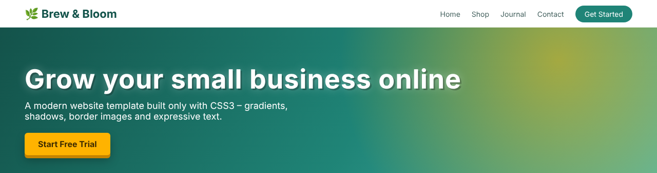
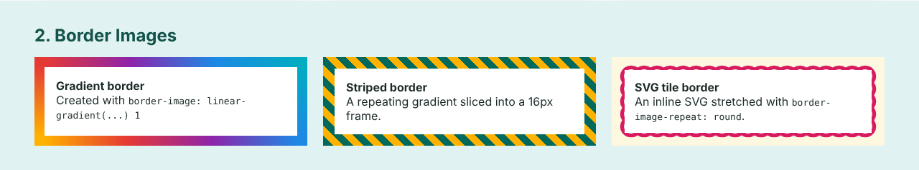
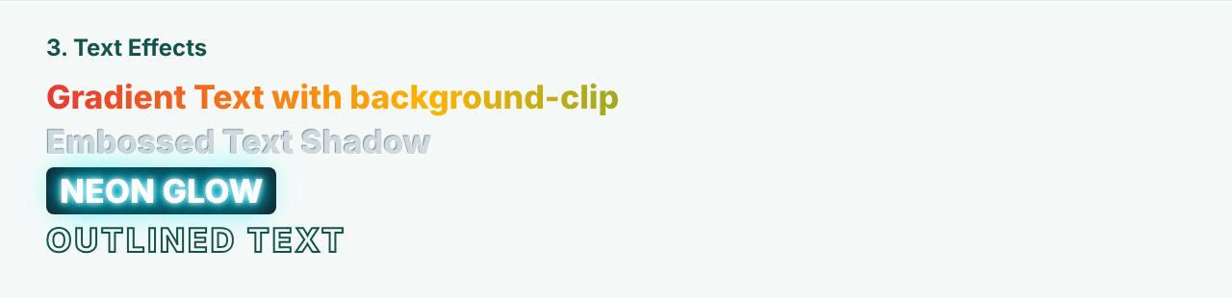

3.6 Explanation of the Output
- The hero banner uses two background layers. The upper layer is a radial gradient with a translucent amber colour; the lower is a linear gradient from dark teal to light teal. background-size: cover makes it fill the whole banner.
- The headline has two text-shadows, a hard dark offset one and a soft white glow, which makes the white letters stand out from the background.
- The first row of cards demonstrates three shadow styles. The glass card uses an rgba background, the inset card appears pressed into the page.
- The three frames in the second section are not images downloaded from a server. They are produced by gradients and an inline SVG, so they scale without loss of quality.
- The last section shows four text effects. The gradient text is possible because the background is clipped to the shape of the letters and the text colour is transparent.

3.7 Result
A modern, template-style web page was developed using CSS3 only. The features of backgrounds (multiple layers and gradients), border images, RGBA/HSLA colours, box shadows and text shadows were implemented with code and were verified in the browser output. These features reduce the use of image files, speed up page loading and make the design scalable.

Question 4: Contemporary Web Page with CSS3 Transformations, Transitions and Animations (Marquee) using Key Frames

4.1 Aim
To design a contemporary web page that uses CSS3 transforms, transitions and animations, to demonstrate the different types of 2D and 3D transformations, and to show how animations, including a scrolling marquee, are implemented with @keyframes.

4.2 Design Concept
The page, named Orbit Labs, uses a dark theme with neon accent colours, which is the style of many contemporary technology websites. It has a scrolling news ticker at the top and four sections: (A) 2D transforms, (B) 3D transforms, (C) transitions that react to the mouse, and (D) keyframe animations that run continuously. No JavaScript is used; all movement is created by CSS3.

4.3 CSS3 Transforms
The transform property changes the shape and position of an element without affecting the layout of other elements. The element is transformed around the point set by transform-origin (the centre by default).

4.3.1 2D transform functions
Function | Effect | Example in the page
translate(x, y), translateX(), translateY() | Moves the element | translate(18px, -12px)
rotate(angle) | Turns the element clockwise (positive) or anticlockwise | rotate(25deg)
scale(x, y) | Enlarges or shrinks | scale(1.35)
skew(x-angle, y-angle) | Slants the element along the axes | skew(-18deg, 6deg)
matrix(a, b, c, d, e, f) | Combines all 2D transforms in one function | matrix(1, 0.3, -0.3, 1, 0, 0)
Combination | Functions are applied from right to left | translateX(10px) rotate(-15deg) scale(1.2)

4.3.2 3D transform functions
The parent element needs the perspective property to give depth. The functions rotateX(), rotateY(), rotateZ(), translateZ(), scale3d() and matrix3d() then move the element in three-dimensional space. In the page, rotateX(55deg) tilts the box backwards, rotateY(55deg) turns it sideways and the combination of both shows a box in full 3D position.

4.4 CSS3 Transitions
A transition makes a change of a property happen smoothly over a period of time instead of instantly. It requires two states, for example the normal state and the :hover state. The properties are:
Property | Meaning | Values used
transition-property | Which property to animate | transform, background, border-radius, box-shadow
transition-duration | Time taken | 0.6s, 1.2s
transition-timing-function | Speed curve | ease-in-out, cubic-bezier(.68,-.55,.27,1.55), steps(6)
transition-delay | Waiting time before the start | Not used (0s)

4.5 CSS3 Animations and @keyframes
An animation can contain many stages. The stages are written in an @keyframes rule, where percentages (or from and to) specify the style at each moment of the cycle. The rule is attached to an element with the animation properties.
Property | Meaning
animation-name | Name of the @keyframes rule
animation-duration | Length of one cycle
animation-timing-function | ease, linear, ease-in-out, cubic-bezier()
animation-delay | Time before the animation starts; used to stagger the loader bars
animation-iteration-count | Number of repetitions, or infinite
animation-direction | normal, reverse, alternate
animation-fill-mode | Style kept before or after running
animation-play-state | running or paused; used to pause the marquee on hover

General form: @keyframes name { 0% { ... } 50% { ... } 100% { ... } } followed by .element { animation: name 2s ease-in-out infinite; }.

4.6 Marquee Effect
The HTML <marquee> element produces scrolling text, but it is obsolete and is not part of HTML5. The same effect is produced in modern pages with a keyframe animation: the text is placed in a span that begins outside the right edge (padding-left: 100%) and an animation moves it left with translateX(0) to translateX(-100%) in a linear infinite loop. The parent has overflow: hidden and white-space: nowrap. An extra rule, animation-play-state: paused on :hover, lets the visitor stop the ticker to read it.
Source code: q4.html
<!DOCTYPE html>
<html lang="en">
<head>
<meta charset="UTF-8">
<meta name="viewport" content="width=device-width, initial-scale=1.0">
<link rel="icon" href="data:,">
<title>Orbit Labs | CSS3 Transforms, Transitions &amp; Animations</title>
<style>
* { box-sizing: border-box; }
body { margin: 0; font-family: "Segoe UI", Arial, sans-serif; background: #0b1020; color: #e8eaf6; }
header { padding: 26px 40px 10px; }
header h1 { margin: 0; font-size: 34px; background: linear-gradient(90deg, #7c4dff, #00e5ff); -webkit-background-clip: text; background-clip: text; color: transparent; }
header p { margin: 4px 0 0; color: #9fa8da; }

/* ===== MARQUEE using @keyframes (replaces deprecated <marquee>) ===== */
.marquee { overflow: hidden; white-space: nowrap; background: #1a237e; border-top: 2px solid #7c4dff; border-bottom: 2px solid #00e5ff; margin: 14px 0; }
.marquee span { display: inline-block; padding: 9px 0; padding-left: 100%; animation: scroll-left 14s linear infinite; font-weight: 600; letter-spacing: 1px; }
.marquee:hover span { animation-play-state: paused; }
@keyframes scroll-left { from { transform: translateX(0); } to { transform: translateX(-100%); } }

h2 { font-size: 18px; margin: 0 0 12px; color: #80deea; }
section { padding: 14px 40px; }
.row { display: grid; grid-template-columns: repeat(6, 1fr); gap: 16px; }
.cell { text-align: center; font-size: 12px; color: #b0bec5; }
.box { width: 96px; height: 96px; margin: 22px auto 24px; border-radius: 12px; display: grid; place-items: center; font-weight: 700; color: #fff; background: linear-gradient(135deg, #7c4dff, #00bcd4); }

/* ===== 2D TRANSFORMS (static, to show each type) ===== */
.t-rotate { transform: rotate(25deg); }
.t-scale { transform: scale(1.35); }
.t-translate { transform: translate(18px, -12px); }
.t-skew { transform: skew(-18deg, 6deg); }
.t-matrix { transform: matrix(1, 0.3, -0.3, 1, 0, 0); }
.t-combo { transform: translateX(10px) rotate(-15deg) scale(1.2); }

/* ===== 3D TRANSFORMS ===== */
.persp { perspective: 400px; }
.t-rx { transform: rotateX(55deg); }
.t-ry { transform: rotateY(55deg); }
.t-rz3d { transform: rotateX(40deg) rotateY(-35deg); }

/* ===== TRANSITIONS (triggered by :hover) ===== */
.trans .box { transition: transform 0.6s ease-in-out, background 0.6s, border-radius 0.6s, box-shadow 0.6s; }
.trans .a:hover { transform: rotate(180deg) scale(1.2); border-radius: 50%; }
.trans .b:hover { background: linear-gradient(135deg, #ff5252, #ffab40); transform: translateY(-14px); box-shadow: 0 18px 24px rgba(0, 0, 0, 0.5); }
.trans .c { transition-timing-function: cubic-bezier(.68, -.55, .27, 1.55); }
.trans .c:hover { transform: translateX(26px) skew(-12deg); }
.trans .d { transition: transform 1.2s steps(6); }
.trans .d:hover { transform: rotate(120deg); }

/* ===== KEYFRAME ANIMATIONS ===== */
@keyframes spin { to { transform: rotate(360deg); } }
@keyframes pulse { 0%, 100% { transform: scale(1); box-shadow: 0 0 0 0 rgba(0, 229, 255, .6); } 50% { transform: scale(1.18); box-shadow: 0 0 0 18px rgba(0, 229, 255, 0); } }
@keyframes bounce { 0%, 100% { transform: translateY(0); } 40% { transform: translateY(-36px); } 60% { transform: translateY(-36px); } 80% { transform: translateY(4px); } }
@keyframes morph { 0% { border-radius: 12px; background: #7c4dff; } 50% { border-radius: 50%; background: #ff4081; transform: rotate(180deg); } 100% { border-radius: 12px; background: #7c4dff; transform: rotate(360deg); } }
@keyframes flip { 0% { transform: perspective(400px) rotateY(0); } 100% { transform: perspective(400px) rotateY(360deg); } }
@keyframes wave { 0%, 100% { transform: translateX(-14px) rotate(-8deg); } 50% { transform: translateX(14px) rotate(8deg); } }
.an-spin { animation: spin 3s linear infinite; }
.an-pulse { animation: pulse 1.8s ease-in-out infinite; }
.an-bounce { animation: bounce 1.6s ease infinite; }
.an-morph { animation: morph 4s ease-in-out infinite; }
.an-flip { animation: flip 3.5s ease-in-out infinite; }
.an-wave { animation: wave 2.2s ease-in-out infinite alternate; }

/* Loader bars */
.bars { display: flex; gap: 6px; justify-content: center; align-items: flex-end; height: 60px; }
.bars i { width: 10px; background: #00e5ff; border-radius: 3px; animation: grow 1s ease-in-out infinite; }
.bars i:nth-child(2) { animation-delay: .15s; } .bars i:nth-child(3) { animation-delay: .3s; }
.bars i:nth-child(4) { animation-delay: .45s; } .bars i:nth-child(5) { animation-delay: .6s; }
@keyframes grow { 0%, 100% { height: 10px; } 50% { height: 56px; } }

footer { text-align: center; padding: 14px; font-size: 12px; color: #7986cb; }
</style>
</head>
<body>

<header>
<h1>ORBIT LABS</h1>
<p>A contemporary single-page design driven entirely by CSS3 motion</p>
</header>

<div class="marquee"><span>&#9889; NEW: CSS3 transforms &bull; smooth transitions &bull; keyframe animations &bull; zero JavaScript &bull; works in every modern browser &#9889;</span></div>

<section>
<h2>A. 2D Transforms</h2>
<div class="row">
<div class="cell"><div class="box t-rotate">rotate</div>rotate(25deg)</div>
<div class="cell"><div class="box t-scale">scale</div>scale(1.35)</div>
<div class="cell"><div class="box t-translate">move</div>translate(18px,-12px)</div>
<div class="cell"><div class="box t-skew">skew</div>skew(-18deg,6deg)</div>
<div class="cell"><div class="box t-matrix">matrix</div>matrix(1,.3,-.3,1,0,0)</div>
<div class="cell"><div class="box t-combo">combo</div>translate + rotate + scale</div>
</div>
</section>

<section>
<h2>B. 3D Transforms</h2>
<div class="row persp">
<div class="cell"><div class="box t-rx">rotateX</div>rotateX(55deg)</div>
<div class="cell"><div class="box t-ry">rotateY</div>rotateY(55deg)</div>
<div class="cell"><div class="box t-rz3d">X + Y</div>rotateX(40) rotateY(-35)</div>
<div class="cell" style="grid-column: span 3; text-align:left; padding-top:30px">Parent uses <code>perspective: 400px</code> so rotated boxes appear to recede in 3D space.</div>
</div>
</section>

<section class="trans">
<h2>C. Transitions (hover each box)</h2>
<div class="row">
<div class="cell"><div class="box a">spin</div>transform + radius</div>
<div class="cell"><div class="box b">lift</div>colour + shadow</div>
<div class="cell"><div class="box c">slide</div>cubic-bezier</div>
<div class="cell"><div class="box d">steps</div>steps(6)</div>
<div class="cell" style="grid-column: span 2; text-align:left; padding-top:30px">Transition = animation between <b>two</b> states (normal &rarr; :hover).</div>
</div>
</section>

<section>
<h2>D. @keyframes Animations</h2>
<div class="row">
<div class="cell"><div class="box an-spin">spin</div>0% &rarr; 100%</div>
<div class="cell"><div class="box an-pulse">pulse</div>0%, 50%, 100%</div>
<div class="cell"><div class="box an-bounce">bounce</div>5 key stops</div>
<div class="cell"><div class="box an-morph">morph</div>shape + colour</div>
<div class="cell"><div class="box an-flip">flip</div>3D rotateY</div>
<div class="cell"><div class="box an-wave">wave</div>alternate</div>
</div>
<div class="bars" style="margin-top:12px"><i></i><i></i><i></i><i></i><i></i></div>
</section>

<footer>Orbit Labs &bull; Internet Programming CSA43 &bull; Assignment 1 &ndash; Question 4</footer>
</body>
</html>

4.8 Output Screenshots
Animations cannot be shown in a single still picture, so screenshots were captured at different moments of time and with the mouse placed over the elements.
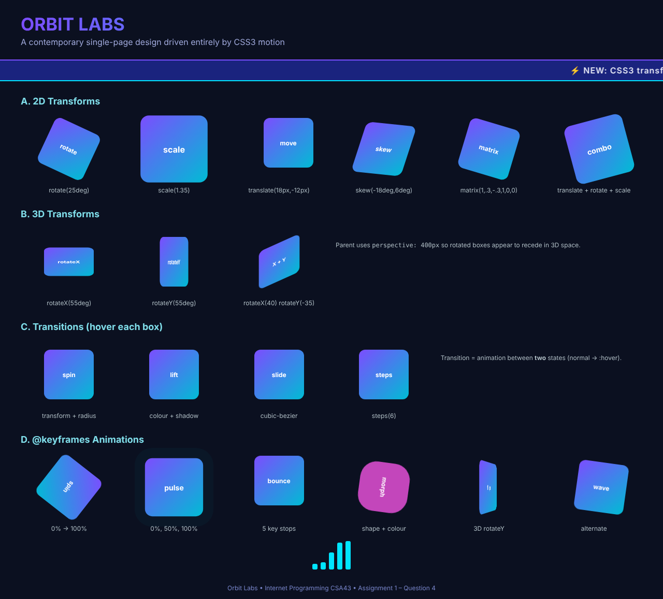

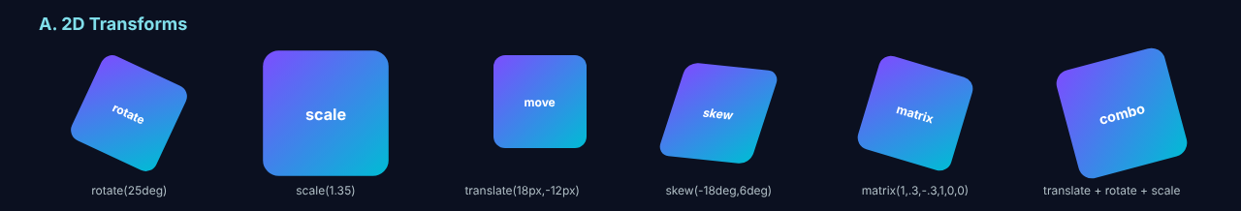
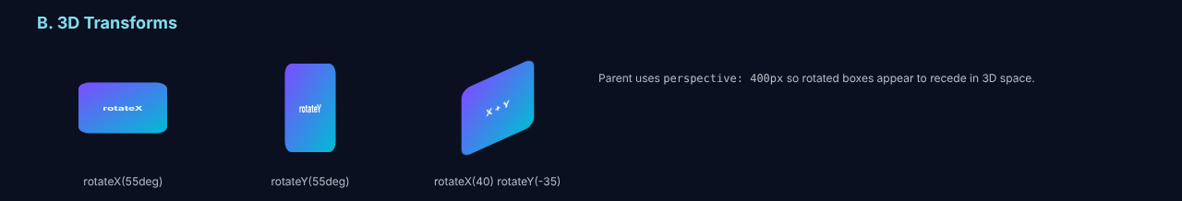
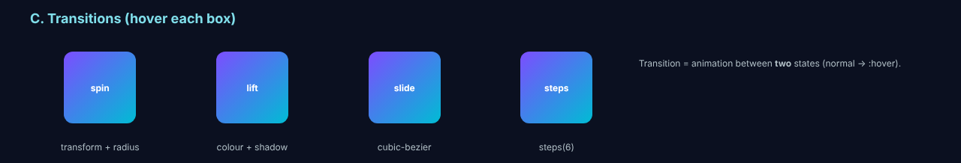
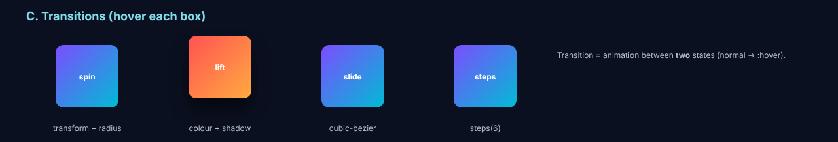
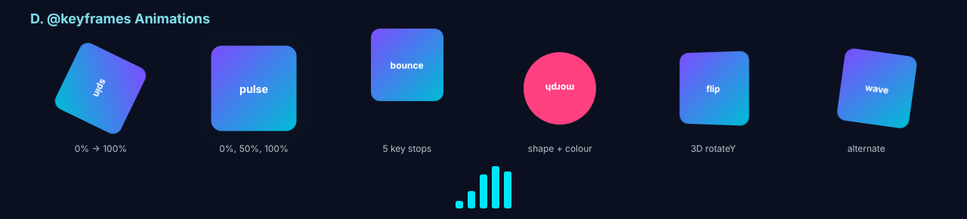

4.9 Explanation of the Output
- In Figure 4.4 each box shows one transformation type with the function written below it. The box with scale(1.35) is larger than its neighbours without moving them, because transforms do not change the layout.
- In Figure 4.5 the three boxes appear to lie in depth, as the parent has perspective: 400px.
- Comparing Figures 4.6, 4.7 and 4.8 shows the transitions: the same boxes change smoothly to a new state when the mouse is placed over them, and they return to the original state when the mouse is removed.
- Figures 4.9 to 4.11 are three moments of the same page. The spin box has a different angle in each, the pulse box grows and shrinks with an expanding ring, the bounce box jumps and the flip box turns around the vertical axis. This proves that the @keyframes animations run continuously.
- Figures 4.2 and 4.3 are taken five seconds apart. The ticker text is at a different place, which proves the marquee animation.

4.10 Difference between Transition and Animation
Point | Transition | Animation
Trigger | Needs an event or state change such as :hover | Can start automatically on page load
Stages | Only two (start and end) | Many stages using @keyframes
Repetition | Runs once per change | Can run infinitely
Control | Limited | Full control with delay, direction, fill-mode and play-state

4.11 Result
A contemporary page was designed that implements 2D and 3D transformations, hover transitions, a keyframe-based marquee and a set of keyframe animations. The output screenshots at different moments confirm that all the effects work correctly in the browser using CSS3 only.
Question 5: Architecture, Features and Working Principles of Progressive Web Applications (PWA)

5.1 Aim
To design the architecture of a Progressive Web Application, to explain its features and working principles, and to discuss the roles of service workers, the web app manifest, caching strategies and push notifications in providing an enhanced user experience. A working example, Pothigai Daily News, was developed and tested including offline mode.

5.2 Introduction
A Progressive Web Application is a web application that is built with standard web technologies (HTML, CSS and JavaScript) but behaves like a native mobile application. It can be installed on the home screen, works with a poor or no network connection, receives notifications and opens in its own window. The word "progressive" means that the application works for every user in every browser as a basic web page and gains extra capabilities progressively in browsers that support them. A PWA has one code base for all platforms, does not need an app store and is updated simply by updating the files on the server.

5.3 Features of a PWA
Feature | Description
Progressive | Works for every user whatever browser is used; advanced features are added when supported.
Responsive | Fits desktop, tablet and mobile screens.
Connectivity independent | Works offline or on slow networks because of the service worker and cache.
App-like | Opens in a standalone window without browser address bar; has app icon and splash screen.
Fresh | Always up to date through the service-worker update process.
Safe | Served over HTTPS (localhost during development) to prevent tampering.
Discoverable | Identified as an application by the manifest and found by search engines.
Re-engageable | Push notifications bring users back to the application.
Installable | Can be added to the home screen without an app store.
Linkable | Shared by a simple URL.

5.4 Architecture of a PWA
The architecture of a PWA is built from three technical pillars: HTTPS, a web app manifest and a service worker. They work with the application shell, the browser storage APIs and the remote servers as shown in Figure 5.1.
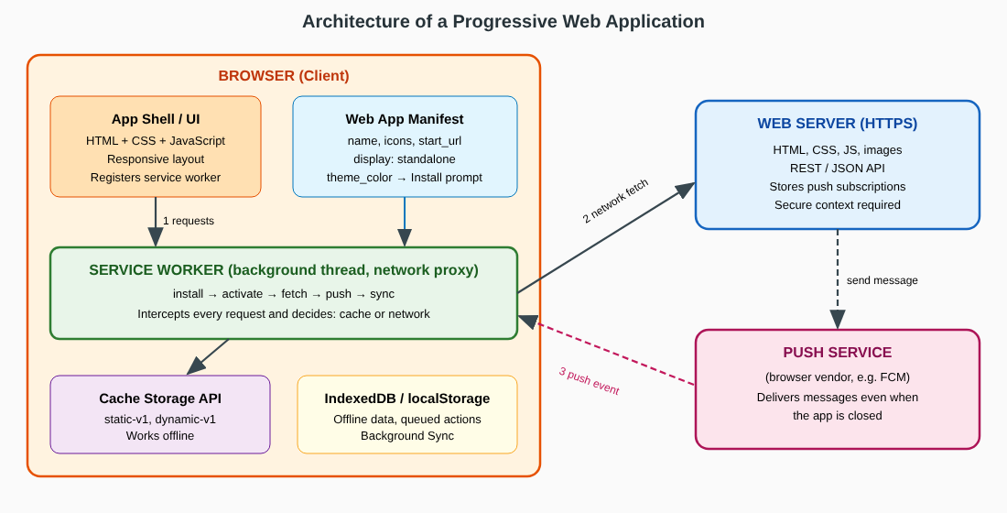

Architecture Web Application
The components of the architecture are:
- Application shell (UI layer). The minimum HTML, CSS and JavaScript that is required to display the user interface. It is cached at the first visit so that later visits load immediately, and dynamic content is then filled into the shell.
- Web app manifest. A JSON file that tells the browser how the application should appear when installed.
- Service worker. A JavaScript file that runs in a separate background thread and acts as a programmable network proxy between the page, the browser cache and the network.
- Storage layer. Cache Storage API for files and responses, IndexedDB for structured data, and localStorage for small settings.
- Web server. Supplies the files and the API over HTTPS and stores the push subscriptions.
- Push service. A service operated by the browser vendor that delivers push messages to the browser even when the application is not open.

5.5 Working Principle
- The user opens the URL. The browser downloads the page and reads the <link rel="manifest"> element.
- The page script calls navigator.serviceWorker.register("/sw.js"). The browser downloads the service worker file and starts its life cycle.
- Install event: the service worker opens a cache and stores the application-shell files (pre-caching).
- Activate event: old caches from earlier versions are deleted and the worker takes control of the open pages.
- Fetch event: from now on every request of the page passes through the service worker, which applies a caching strategy and answers from the cache or from the network.
- When the browser decides that the PWA criteria are met, it fires the beforeinstallprompt event and the user can install the application.
- If the user permits notifications, the page subscribes to the push service. The server later sends a message to the push service, which wakes the service worker and raises the push event, and the worker shows the notification.

5.6 Role of Service Workers
A service worker is an event-driven script that runs independently of the web page. It has no access to the DOM, it works asynchronously through promises, and it works only on secure origins. Its life cycle is: registered → installing → installed (waiting) → activating → activated → redundant. Its important roles are:
- Intercepting network requests (fetch event) and deciding whether the answer comes from the cache or the network.
- Pre-caching the application shell during the install event and cleaning old caches during the activate event.
- Providing offline support, so the page opens even when the device has no connection.
- Receiving push messages and showing notifications (push and notificationclick events).
- Background synchronisation: queuing user actions made offline and sending them when the connection returns.
- Controlling updates: a new sw.js file with a changed cache name is installed in the background and replaces the old worker after activation.

5.7 Role of the Web App Manifest
The manifest is a JSON file linked by <link rel="manifest" href="manifest.json">. It turns the website into an installable application by giving the browser the information that a native application would place in its package.
Member | Purpose | Value in the example
name and short_name | Full name for the install dialog; short name for the home-screen label | Pothigai Daily News; PDNews
start_url | Page opened when the app is launched | /q5.html
scope | URLs that belong to the app | /
display | fullscreen, standalone, minimal-ui or browser | standalone
orientation | Preferred screen orientation | portrait
background_color | Colour of the splash screen | #fff8e1
theme_color | Colour of the toolbar or title bar | #e65100
icons | Icons of different sizes (192×192 and 512×512 are required) | icon-192.png, icon-512.png

5.8 Caching Strategies
The choice of the caching strategy decides the balance between speed and freshness. The service worker can use a different strategy for each type of request.
Strategy | How it works | Best used for | Used in example
Cache first (cache falling back to network) | Looks in the cache; goes to the network only if the file is not stored. | Static files that rarely change: shell, fonts, icons | Application shell
Network first (network falling back to cache) | Tries the network; if it fails, serves the stored copy. | Frequently changing data such as news or prices | /api/ requests
Stale while revalidate | Returns the cached copy at once and updates the cache from the network in the background. | Images, avatars, non-critical content | Images
Cache only | Answers only from the cache. | Files placed in the cache at install time | —
Network only | Always uses the network. | Payments, login, live data | —

5.9 Push Notifications
Push notifications let the server contact users even when the application is closed. Two different APIs work together: the Push API, which receives messages from the server through the push service, and the Notifications API, which displays them. The steps are:
- The page asks the user for permission with Notification.requestPermission().
- If the user allows it, the page calls registration.pushManager.subscribe() and receives a subscription object that contains an endpoint URL and encryption keys.
- The subscription is sent to the application server and saved.
- When news is available, the server sends an encrypted message (Web Push protocol with VAPID keys) to the endpoint.
- The push service delivers it to the browser and wakes the service worker.
- The service worker's push event handler calls registration.showNotification(title, options).
- When the user taps the notification, the notificationclick handler opens or focuses the application window.
Notifications should be sent only for useful and timely information, because users can withdraw the permission at any time.

5.10 How these Parts Enhance the User Experience
Component | Benefit seen by the user
Service worker with pre-cache | The application starts almost instantly and opens even in a train tunnel or a lift with no signal.
Caching strategies | Static parts load from the device; news stays fresh when the network is present.
Manifest | Application icon on the home screen, full-screen window, splash screen and branded colours, just like a native app.
Push notifications | The user receives breaking news without opening the site.
HTTPS | Data is protected from interception.
Responsive design | One application serves phone, tablet and desktop.

5.11 Implementation Programs
The example application consists of four files: q5.html (page and registration script), manifest.json, sw.js (service worker), and two PNG icons that were generated for the application.
Source code: saving file .html
<!DOCTYPE html>
<html lang="en">
<head>
<meta charset="UTF-8">
<meta name="viewport" content="width=device-width, initial-scale=1.0">
<meta name="theme-color" content="#e65100">
<link rel="manifest" href="manifest.json">
<link rel="icon" href="icon-192.png">
<title>Pothigai Daily News | PWA Demo</title>
<style>
* { box-sizing: border-box; }
body { margin: 0; font-family: "Segoe UI", Arial, sans-serif; background: #fff8e1; color: #3e2723; }
header { background: #e65100; color: #fff; padding: 18px 32px; display: flex; justify-content: space-between; align-items: center; }
header h1 { margin: 0; font-size: 26px; }
header small { opacity: .85; }
.badge { padding: 4px 12px; border-radius: 20px; font-size: 13px; font-weight: 700; }
.on { background: #2e7d32; } .off { background: #b71c1c; }
main { max-width: 980px; margin: 0 auto; padding: 22px; display: grid; grid-template-columns: 1fr 1fr; gap: 18px; }
.panel { background: #fff; border-radius: 10px; padding: 16px 20px; box-shadow: 0 2px 8px rgba(0,0,0,.14); }
.panel h2 { margin: 0 0 10px; font-size: 17px; color: #bf360c; }
.full { grid-column: 1 / -1; }
ul { margin: 0; padding-left: 20px; }
li { margin: 4px 0; font-size: 14px; }
.ok::marker { content: "\2705 "; } .no::marker { content: "\274C "; }
button { background: #e65100; color: #fff; border: 0; padding: 9px 16px; border-radius: 6px; font-size: 14px; cursor: pointer; margin: 4px 6px 4px 0; }
pre { background: #263238; color: #aed581; padding: 10px; border-radius: 6px; font-size: 12px; overflow: auto; margin: 8px 0 0; }
.news article { border-bottom: 1px solid #ffe0b2; padding: 8px 0; }
.news article:last-child { border: 0; }
.news h3 { margin: 0; font-size: 15px; } .news p { margin: 2px 0 0; font-size: 13px; color: #6d4c41; }
</style>
</head>
<body>

<header>
<div><h1>&#128240; Pothigai Daily News</h1><small>Progressive Web App &ndash; installable, offline, notifying</small></div>
<span id="net" class="badge on">ONLINE</span>
</header>

<main>
<section class="panel">
<h2>PWA Checklist (live results)</h2>
<ul id="checks"></ul>
</section>

<section class="panel">
<h2>Controls</h2>
<button id="btnInstall">Install App</button>
<button id="btnNotify">Enable Notifications</button>
<button id="btnCache">Show Cache Contents</button>
<pre id="log">Waiting for service worker...</pre>
</section>

<section class="panel news full">
<h2>Latest Headlines (served from cache when offline)</h2>
<article><h3>Chennai Metro Phase II opens first stretch</h3><p>Commuters on the Porur line report a 20-minute saving on weekday mornings.</p></article>
<article><h3>State announces free coding labs in 500 schools</h3><p>The programme starts next term with web development as the first module.</p></article>
<article><h3>Northeast monsoon arrives two days early</h3><p>Coastal districts are advised to keep umbrellas and power banks handy.</p></article>
</section>

<section class="panel full">
<h2>Web App Manifest in use</h2>
<pre id="manifest">loading manifest...</pre>
</section>
</main>

<script>
var log = function (t) { document.getElementById('log').textContent = t; };
var checks = document.getElementById('checks');
function add(ok, text) { var li = document.createElement('li'); li.className = ok ? 'ok' : 'no'; li.textContent = text; checks.appendChild(li); }

// Online / offline indicator
function net() { var el = document.getElementById('net'); el.textContent = navigator.onLine ? 'ONLINE' : 'OFFLINE'; el.className = 'badge ' + (navigator.onLine ? 'on' : 'off'); }
window.addEventListener('online', net); window.addEventListener('offline', net); net();

// Show manifest content
fetch('manifest.json').then(function (r) { return r.text(); }).then(function (t) { document.getElementById('manifest').textContent = t; });

// Register service worker
var swReady = Promise.resolve();
if ('serviceWorker' in navigator) {
swReady = navigator.serviceWorker.register('/sw.js').then(function (reg) {
return navigator.serviceWorker.ready.then(function () {
add(true, 'Service worker registered, scope: ' + reg.scope);
log('Service worker active.\nState: ' + (reg.active ? reg.active.state : 'n/a') + '\nApp shell pre-cached.');
});
}).catch(function (e) { add(false, 'Service worker failed: ' + e.message); });
} else { add(false, 'Service workers not supported'); }

add(!!document.querySelector('link[rel=manifest]'), 'Web app manifest linked');
add(location.protocol === 'https:' || location.hostname === 'localhost', 'Secure context (HTTPS or localhost)');
add('PushManager' in window, 'Push API available');
add('Notification' in window, 'Notifications API available');
add('caches' in window, 'Cache Storage API available');

// Install prompt
var deferred;
window.addEventListener('beforeinstallprompt', function (e) { e.preventDefault(); deferred = e; });
document.getElementById('btnInstall').onclick = function () { if (deferred) { deferred.prompt(); } else { log('Install prompt not available in this browser state.'); } };

// Notifications
document.getElementById('btnNotify').onclick = function () {
Notification.requestPermission().then(function (p) {
log('Notification permission: ' + p);
if (p === 'granted') navigator.serviceWorker.ready.then(function (r) { r.showNotification('Pothigai Daily News', { body: 'Notifications are now enabled.' }); });
});
};

// Show cache
document.getElementById('btnCache').onclick = showCache;
function showCache() {
caches.keys().then(function (names) {
return Promise.all(names.map(function (n) { return caches.open(n).then(function (c) { return c.keys().then(function (reqs) { return n + ':\n ' + reqs.map(function (r) { return new URL(r.url).pathname; }).join('\n '); }); }); }));
}).then(function (rows) { log(rows.join('\n') || 'No caches yet'); });
}
window.showCache = showCache;
</script>
</body>
</html>

Source code: manifest.json
{
"name": "Pothigai Daily News",
"short_name": "PDNews",
"description": "An installable, offline-capable news reader built as a Progressive Web App",
"start_url": "/q5.html",
"scope": "/",
"display": "standalone",
"orientation": "portrait",
"background_color": "#fff8e1",
"theme_color": "#e65100",
"icons": [
{ "src": "icon-192.png", "sizes": "192x192", "type": "image/png", "purpose": "any maskable" },
{ "src": "icon-512.png", "sizes": "512x512", "type": "image/png" }
]
}

Source code: sw.js
// sw.js - Service Worker for Pothigai Daily News
const STATIC_CACHE = 'pdn-static-v1';
const DYNAMIC_CACHE = 'pdn-dynamic-v1';
const APP_SHELL = ['/q5.html', '/manifest.json', '/icon-192.png', '/icon-512.png'];

// 1. INSTALL - pre-cache the app shell
self.addEventListener('install', (event) => {
event.waitUntil(caches.open(STATIC_CACHE).then((cache) => cache.addAll(APP_SHELL)));
self.skipWaiting();
});

// 2. ACTIVATE - delete old caches
self.addEventListener('activate', (event) => {
event.waitUntil(
caches.keys().then((keys) =>
Promise.all(keys.filter((k) => k !== STATIC_CACHE && k !== DYNAMIC_CACHE).map((k) => caches.delete(k)))
).then(() => self.clients.claim())
);
});

// 3. FETCH - choose a caching strategy per request
self.addEventListener('fetch', (event) => {
const url = new URL(event.request.url);

// Strategy A: Network-first for API data (fresh news, fallback to cache)
if (url.pathname.startsWith('/api/')) {
event.respondWith(
fetch(event.request)
.then((res) => { const copy = res.clone(); caches.open(DYNAMIC_CACHE).then((c) => c.put(event.request, copy)); return res; })
.catch(() => caches.match(event.request))
);
return;
}

// Strategy B: Stale-while-revalidate for images
if (event.request.destination === 'image') {
event.respondWith(
caches.open(DYNAMIC_CACHE).then((cache) =>
cache.match(event.request).then((cached) => {
const fetching = fetch(event.request).then((res) => { cache.put(event.request, res.clone()); return res; });
return cached || fetching;
})
)
);
return;
}

// Strategy C: Cache-first for the app shell
event.respondWith(caches.match(event.request).then((cached) => cached || fetch(event.request)));
});

// 4. PUSH - show a notification sent from the server
self.addEventListener('push', (event) => {
const data = event.data ? event.data.text() : 'Breaking news is available';
event.waitUntil(self.registration.showNotification('Pothigai Daily News', { body: data, icon: '/icon-192.png', badge: '/icon-192.png' }));
});

self.addEventListener('notificationclick', (event) => {
event.notification.close();
event.waitUntil(clients.openWindow('/q5.html'));
});

5.12 Output Screenshots
The application was served from localhost (a secure context) and opened in Chrome. After the first visit the page was reloaded so that the service worker took control. Then the network was switched off in the browser and the page was reloaded again to test the offline behaviour.
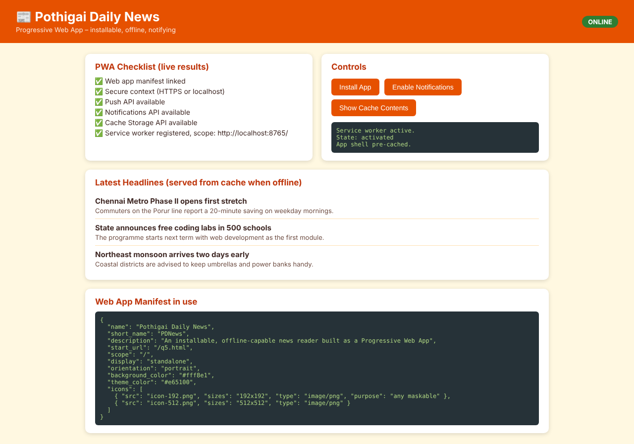

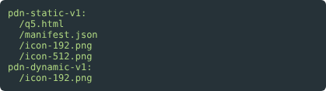
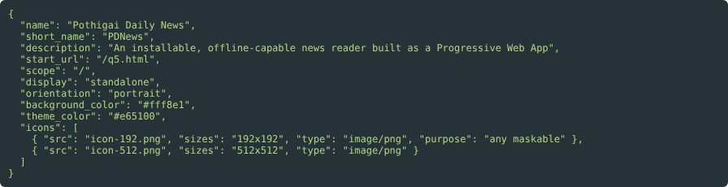

5.13 Explanation of the Output
- Figure 5.2 shows the page as the first visit finishes. The checklist is produced by JavaScript feature detection. All six items are green, which means that the browser supports the PWA technologies and the service worker was registered with the scope http://localhost:8765/.
- The cache listing in Figure 5.4 shows the cache pdn-static-v1 which contains q5.html, manifest.json and the two icon files. These were stored during the install event of sw.js.
- In Figure 5.6 the network connection was switched off. The badge changed to OFFLINE, because the offline event was fired, and the complete page including the headlines and the manifest panel still loaded. The browser could not have received it from the server, so it was delivered by the service worker from the cache. This proves the offline capability.
- The Install App and Enable Notifications buttons use the beforeinstallprompt event and the Notifications API as explained in Sections 5.5 and 5.9. The permission dialog and the installation prompt are controlled by the browser and appear only after a user gesture.

